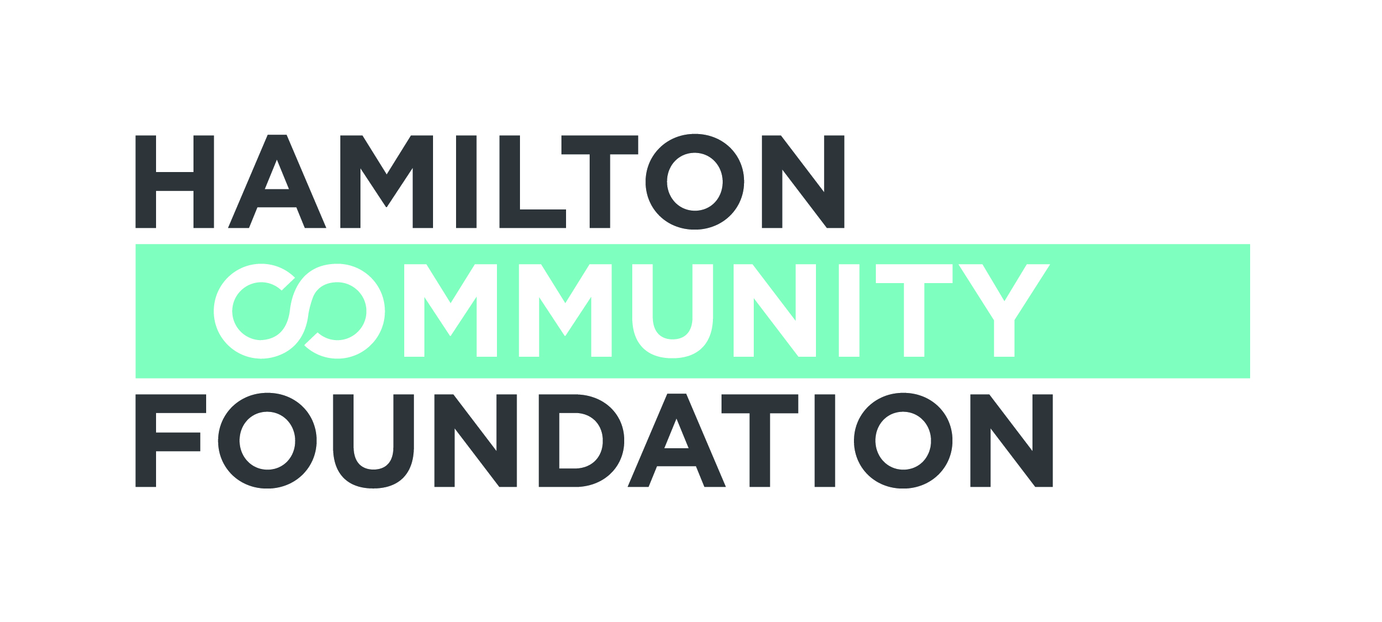

THE SPECTATOR SUMMER CAMP FUND

SURVEY FOR NEW APPLICANTS
Submit with Completed Application Form

To assist us in determining your eligibility for funding from the Spectator Summer Camp Fund please complete the following questions. If you require additional information or have concerns contact Sharon Charters, Grants Manager at (905) 523-5600 x 242.

Organization

Contact Name Phone

Questions:

- How long has your camp/organization been in existence?

- If your organization owns/operates the camp(s), how many children
attend the camp in total, and what percentage of campers are subsidized?

OR,

  - If your organization does not own/operate a camp, which camps do you use?

  - and how do you decide on these specific camps?

- What are the criteria you use to establish financial eligibility of the families requesting subsidy through the Spectator Summer Camp Fund?

- What is the process you use to identify potential campers who meet these criteria?

- Do you access other sources of funding to provide subsidies for campers besides the Spectator Summer Camp Fund?

- What is your policy regarding providing financial subsidies for first time campers vs. repeat campers?

- How do you assess the outcome of the camp experience for the children who are subsidized?

Please submit this survey with your completed application form to:

Hamilton Community Foundation
120 King Street West, Suite 700
Hamilton, Ontario L8P 4V2

