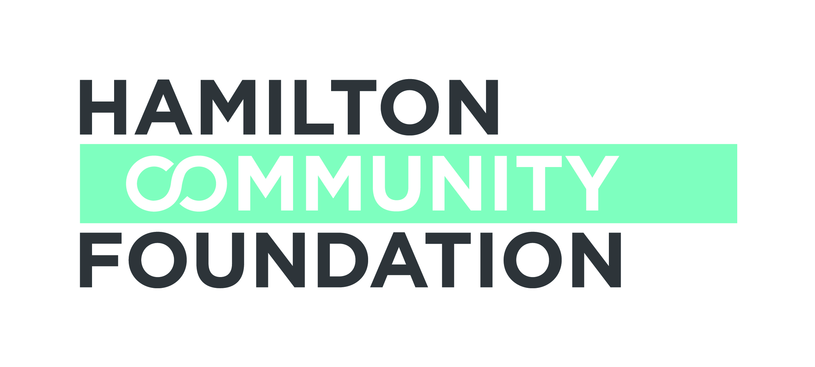

CREATIVE ARTS FUND
HAMILTON COMMUNITY FOUNDATION
FINAL REPORT GUIDELINES

Hamilton Community Foundation requests that you use the following form to prepare a final report on your project. We encourage you to share your insights into what worked, what did not and changes you might make to improve your progress. Your candor and open feedback not only informs us of your progress but provides us with valuable learning experiences that assist us and help other non-profit organizations at the same time.

We ask that you be concise and limit your narrative report to three pages, however feel free to attach detailed evaluation results if appropriate.

Section A

Applicant Name:_________________________________ Grant # ____________________

Telephone: _________________ Fax: ________________ E-mail: ____________________

Contact Person: _____________________________________________________________

Report Prepared By (if different than above): ___________________ Date: _____________

Sponsor Name/Organization (if applicable):________________________________________

Project Title:________________________________________________________________

Report covers period from _____________________ to ___________________________

Number of Persons Served: __________Children ____________ Youth __________ Adults

Total cost of project ___________ Total amount of HCF Grant ___________________

Section B – Narrative

Please follow the format outlined below and ensure that your report does not exceed 3 pages.

Project Activities
- Briefly describe your key project activities during the grant period.

Project Outcomes
- What specific outcomes did you achieve for your target population or community? How did the participants or target audience benefit from your project?
- What changes or improvements, if any, did you make in the project design or delivery to better meet the needs of your target population?
- Describe any unanticipated challenges or successes.
- How successful were you in involving other community partners or funding bodies in your initiative.

Sustainability
- Do you intend to continue this project? If so, how will it be funded? If not, why? How are you progressing in obtaining other sources of support?
- What is your vision for this project over the next three to five years?

Learnings
- What were the key learnings from doing this project? If you were to do it again, what would you change?

Evaluation
- How did you evaluate your project/activities?

Vignette
- Please provide one interesting example of how your project is making a difference

Attachments

- Detailed Financial Statement showing project revenues and expenditures
- One copy of any resource/publicity material produced with funding from Hamilton Community Foundation
- Copies of any media coverage
- Photographs of activities relating to the funded project. Please note that Hamilton Community Foundation uses photographs submitted by grantees in annual reports and other publications. We require a waiver to be submitted with any photograph including project participants allowing for the use of the photograph by the Foundation (available on our website at www.hcf.on.ca )
- Annual report (if available)
- Evaluation reports (if available)

Please direct any questions to:
Sharon Charters, Manager of Grants at 905.523.5600 x 242 or s.charters@hamiltoncommunityfoundation.ca

