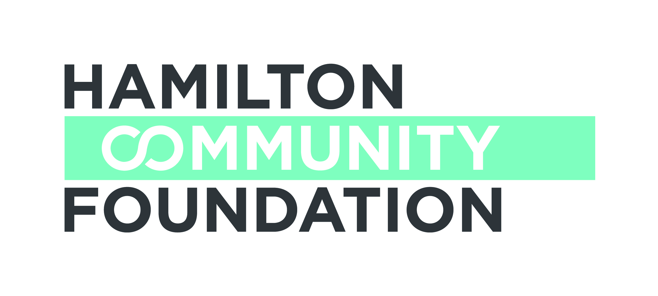

COMMUNITY HEALTH AND EDUCATION RESEARCH (CHER)Grant Application
Part 1 of 2
Due Date: January 6, 2017

Please be advised that this Checklist forms part of your application to the CHER Program. In order for your application to go forward, this form must be completed and signed.

All Applicants:

Two complete copies of the application (including all supporting documentation)

A copy of the project budget

A copy of your latest annual report and/or general information brochure

Indication of approval of Ethics Committee, if applicable

If you are a Community Organization also add:

Signature of the Chair of the Board of Directors and the Executive Director indicating authorization of the application by your organization’s Board of Directors

A signed copy of the partnership agreement between the applicant and the sponsoring
agency, if applicable

A list of current Board members

A copy of the organization’s operating budget for the current year

A copy of the most recent audited financial statements

If you are a Public Agency (ie. University, Hospital, School Board, Municipality):

Signature of the Head of the Department implementing the project

Date: ______________________________
Executive Director or Head of Department Signature

Chairperson of Board of Directors
(Community Organizations only)

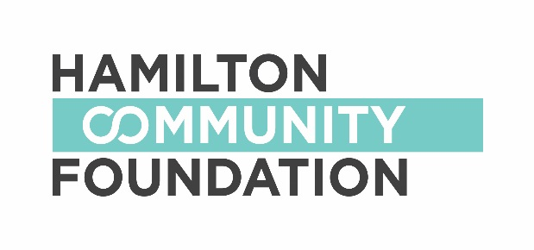

COMMUNITY HEALTH AND EDUCATION RESEARCH (CHER)Grant Application
Part 2 of 2
Due Date: January 6, 2017

Applicant Information

Lead Organization Name:
Address:

Registered Charitable Number:
Telephone: Fax: Website:

Contact Person: Position:
Telephone: Fax: E-mail:
Partner Organization(s), addresses and contact information:

Sponsor Information (if applicable)
Organization Name:
Address:
Registered Charitable Number:
Telephone: Fax: Website:

Contact Person: Position:
Telephone: Fax: E-mail:

Research Project Information
Project Name:
Total Project Budget: $ over months / years
Amount Requested: $ over months / years
CHER Fund Priorities (please select all that apply):
health promotion & disease prevention (enabling people to improve their health by creating conditions in communities for health)
building a healthy community (collaborations for safe, caring, healthy inclusive communities)
integration of best practice in health and social services (dissemination of acquired knowledge and research findings in ways that assist decision makers and practitioners)

Proposal Summary (Please provide a 50 – 100 word summary of your funding request.)

What are you attempting to learn from this research?

Section A: Project Methodology and Outcomes

- Provide evidence of the need for the research project, (e.g. needs assessments, literature review, best practices). Describer how the CHER funding priorities are addressed in your proposed project.

2. Describe the potential of the research to make a significant difference. How will the knowledge gained from the research be used to benefit the community? What will be different because of your research project?

3. Provide a description of the research methodology, the rationale for this methodology and the timelines for the research activities.

Section B: Collaboration and Community Support

4. Describe the role of each of the participants in the proposed collaboration among researchers and community partners (organizations, agencies and institutions).

Section C: Evaluation and Dissemination

5. How will the research results be disseminated?

6. Identify anticipated risks/challenges in undertaking the research and the strategies that will be used to meet these challenges.

Section D: Other

7. Is there any further information you would like to provide concerning this initiative?

Section E: Financial Information

8. Project Budget (Clearly show which items to be supported by HCF funding)

Item | Details | Amount ($)
Total Amount

9. Other Sources of Funding

Source  Organization  Contact Name  Contact Number | Item / Details | Amount | In Kind  or  Financial | Anticipated  or  Confirmed
TOTAL

10. Authorized Signatures

We hereby make application for a grant from the CHER Fund and declare that the information provided in the application form and all required attachments are complete with no misrepresentation.

We understand that submission of this application will not necessarily result in funding support from the Hamilton Community Foundation. Furthermore, we understand that applications may be funded in full or in part, and with some conditions. We understand that staff and volunteers of the Hamilton Community Foundation will review our application.

We certify that this application has official approval from the Board of Directors of the applicant organization.

______________________________ _________________________________
Signature, Executive Director of Name /Title (print)
Applicant*

______________________________ _________________________________
Signature, Chair, Board of Directors Name /Title (print)
of Applicant*

*In the event of a sponsorship, the Executive Director and Board Chair of the organization holding charitable status must sign this Application.

If you have any questions or require assistance, please contact

Sharon Charters at: (905) 523-5600 x 242 / s.charters@hamiltoncommunityfoundation.ca
This application form may be downloaded from our website www.hamiltoncommunityfoundation.ca

Applications must be submitted to the Foundation office,
Suite 700, 120 King Street West, Hamilton, ON L8P 4V2 in HARD COPY ONLY. Submissions via email or facsimile will not be considered.

