CREATIVE ARTS FUND
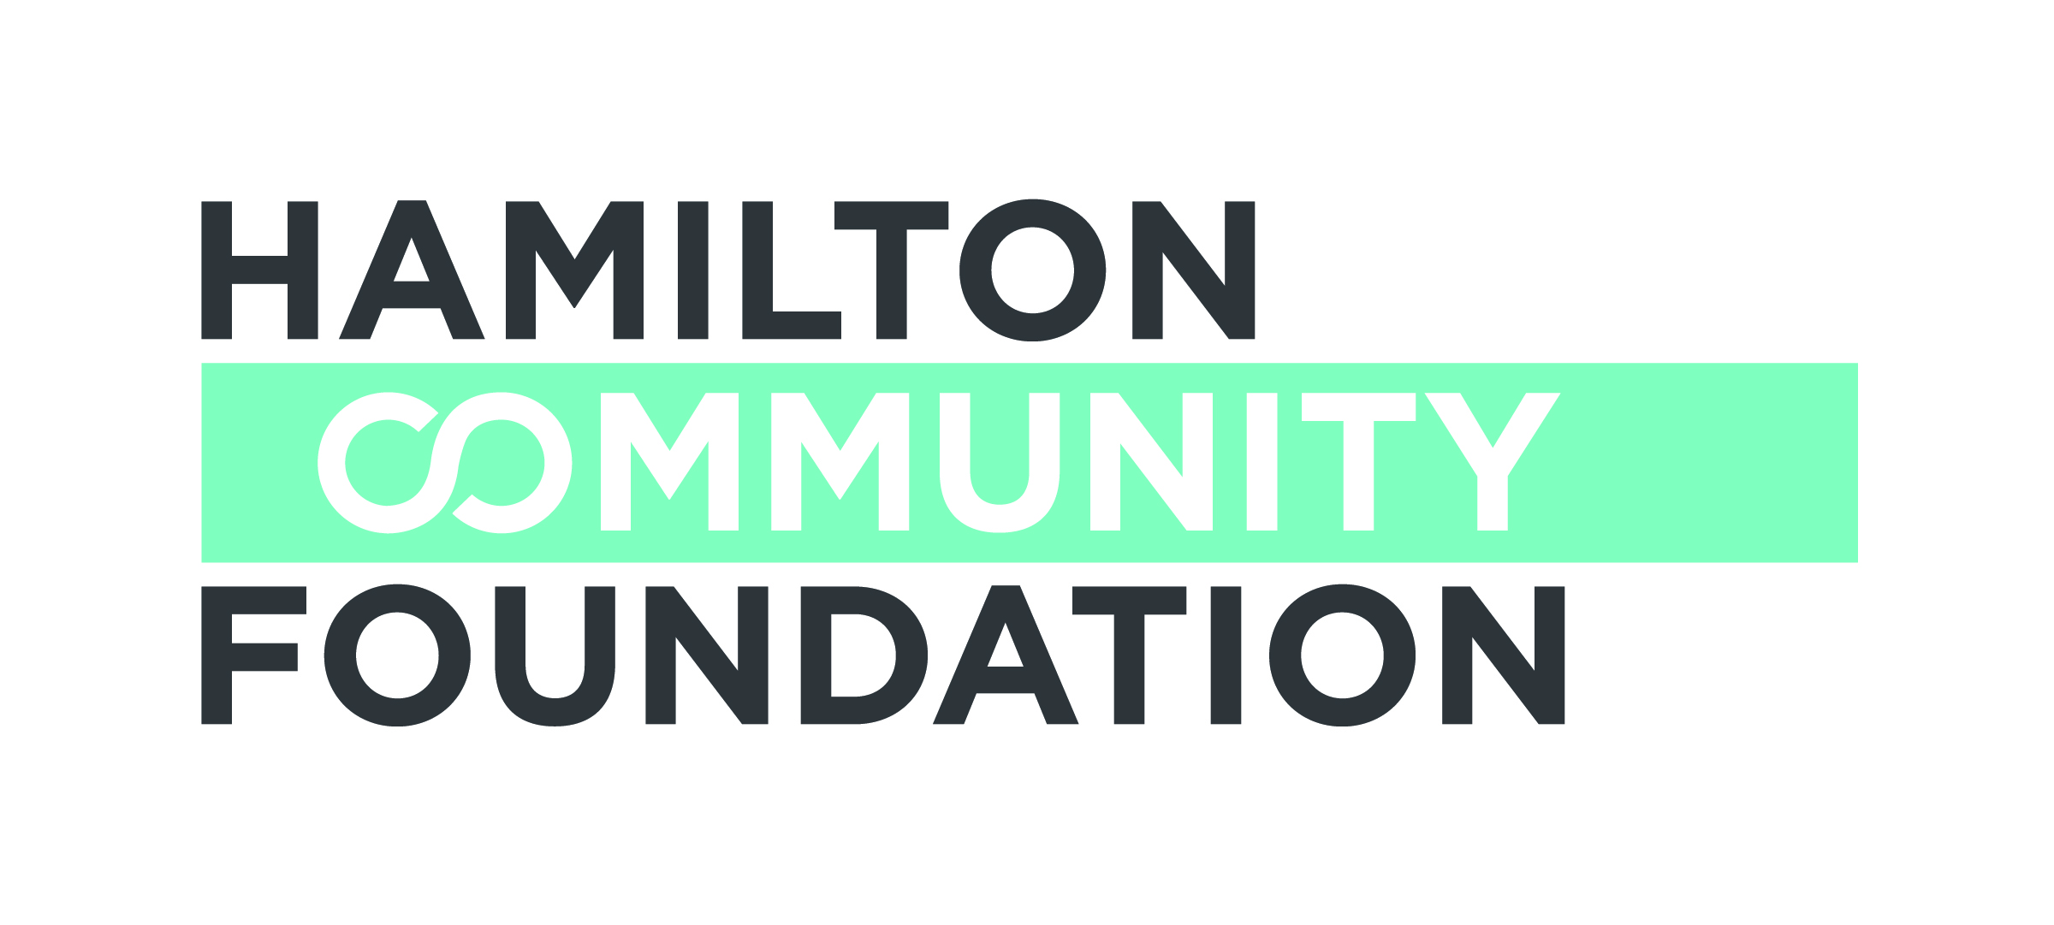
Guidelines
DEADLINE: June 2, 2017
Eligibility:
HCF provides grants for projects that benefit Hamiltonians and by law, grants only to registered Canadian charities and others qualified as described in Section 110 of the Income Tax Act. On occasion, not-for-profit organizations without charitable status may be sponsored by a registered charity under a fiscal sponsorship. More information on fiscal sponsorships is available at http://hamiltoncommunityfoundation.ca/grants/ Please include a partnership agreement if you are applying with a fiscal sponsor.
Please note that Categories 2, 3 and 4 can only be accessed by arts organizations defined as an organization whose mission is primarily dedicated to the arts.
Organizations may submit an application to more than one category.
HCF invites proposals for funding from the Creative Arts Fund in the following categories.
- Community Arts Projects
Grants up to $5,000 are available to support the development and creation of a community arts project. Art practiced at a community level creates a powerful sense of inclusion, understanding and the possibility of self-expression among participants. It can involve one or more art practices, such as music, dance, theatre, visual arts, and storytelling, but the collaborative involvement of professional artists with community members is a necessary component. Please include a resume of the artist(s) involved.
- Support for Arts Presentations
Grants up to $5,000 are available to arts organizations to assist with the costs involved in arts presentations. This category is for both community (volunteer-run) arts organizations and non-profit arts organizations with fewer than five total staff.
- Access to the Arts for Children and Youth
Grants up to $10,000 are available to help ensure access to arts programming for children and youth from families living with low-incomes. This category may include arts instruction as well as subsidizing the cost to attend arts performances.

- Capacity Building Grants
The Capacity building program provides strategic support to non-profit arts organizations. This support is intended to assist in developing administration, financial management and governance structures. The program also provides opportunities for organizational development, planning, and professional development that will have a positive impact on the arts sector in Hamilton. Grants up to $10,000 are available. The Foundation also anticipates some proactive granting in this area. Please note that this category does not include ongoing operating support requests.
While we anticipate most of the grants to cover a period of one year or less, consideration may be given to multi-year requests (up to three years) depending on the initiative.
Application Process:
- An application form is available from the HCF website www.hamiltoncommunityfoundation.ca
- Complete and print the application
- Submit two complete copies of the signed application form and required attachments by the June 2, 2017 deadline

If you received funding for this initiative in 2016-17, you must include a narrative update on the progress of the project as of June 1, 2017.

*In the event of a sponsorship, the Executive Director and Board Chair of the organization holding charitable status must sign the Application.

If you have any questions or require assistance, please contact

Sharon Charters at: (905) 523-5600 x 242 / s.charters@hamiltoncommunityfoundation.ca

Applications must be submitted to the Foundation office,
Suite 700, 120 King Street West, Hamilton, ON L8P 4V2 in HARD COPY ONLY. Submissions via email or facsimile will not be considered.

2

