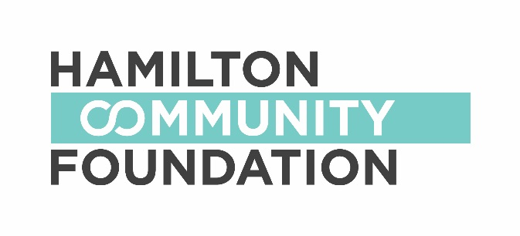

GENERAL APPLICATION FORM

2017-18

Check the fund you wish to apply to:
(PLEASE NOTE ORGANIZATIONS MAY ONLY APPLY TO ONE FUND PER APPLICATION FORM)

Martin Foundation Fund

Focus: grants across sectors with 25% dedicated to the arts.

Grant range: $1,000 - $3,000

Malloch Foundation Fund

Focus: supports a broad array of issues including children, animal welfare, the environment, education, healthcare and adult and adolescent rehabilitation and reform.

Grant range: $1,000 - $2,000

John & Esther Marshall Memorial Fund

Focus: supports arts initiatives

Grant range: $1,000 - $4,000
_______________________________________________________________________________

Applicant Information:
Organization Name:
Address:

Registered Charitable Number:
Telephone: Fax: Website:
Contact Person: Position:
Telephone: Fax: E-mail:

Sponsor Information (if applicable):
Organization Name:
Address:
Registered Charitable Number:
Telephone: Fax: Website:
Contact Person: Position:
Telephone: Fax: E-mail:

Project Information:
Project Name:
Total Project Budget: $

Amount Requested: $

Proposal Summary (Please provide a 50 – 100 word summary of your funding request):

Question One:
Describe your organization / partnership, including your purpose or mission and the services you offer.

Question Two:
If you are applying for a specific project, please list the specific activities you will undertake along with timelines.

Question Three:
List the projected outcomes from this project.

Question Four:
How will this funding be used? Have you received a grant from this fund in the past?

Authorized Signatures:

We hereby make application for a grant from Hamilton Community Foundation and declare that the information provided in the application form and all required attachments are complete with no misrepresentation. We certify that this application has official approval from the organization’s Board of Directors.

_________________________________ ____________________
Signature of Board Chair Date (M/D/Y)

_________________________________
(Name – Please Print)

_________________________________ ____________________
Signature of Executive Director Date (M/D/Y)

_________________________________
(Name – Please Print)

If you have any questions or require assistance, please contact:

Sharon Charters
Manager of Grants
Hamilton Community Foundation, 120 King Street West #700, Hamilton, ON L8P 4V2
e: s.charters@hamiltoncommunityfoundation.ca / t: 905-523-5600 x 242
w: http://www.hamiltoncommunityfoundation.ca

\\hcf-fp\data\Grants and Community Initiatives\Forms & Generic Information\application form for Martin, Malloch, Marshall 2015.dot.docx

