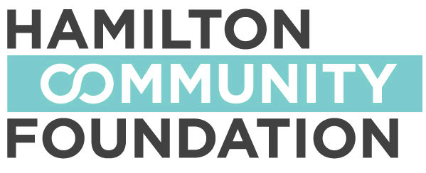
YOUTH-LED GRANTS: 2014-15
Guidelines & Application Form

The Youth Advisory Council of the Hamilton Community Foundation,
invites applications for grants of up to $1,000
to support youth-led community action projects
DEADLINE FOR APPLICATIONS: February 23, 2015

GUIDELINES

WHAT is the program?
The program promotes youth engagement in the community. The program will fund projects proposed by youth, selected by youth, and implemented by youth. This year, we welcome applications focused on both environmental and social justice issues. Suggested areas of focus include income inequality, women’s rights, LGBTQ programming, mental health, education, and extracurricular activities.

WHY this program?
- This is an opportunity for youth to complete a project in the community, neighbourhood or school.
- This is a chance to show leadership and address environmental and social justice issues that youth care about.

WHO can apply?
- Youth must be between the ages of 11 and 25.
- Youth must participate on a volunteer basis.
- Youth must have the use of a charitable registration number affiliated with the organization that has been invited to submit an application.
- Youth must apply as a group, respecting diversity and equal opportunity

HOW do you get involved?
- Plan and organize a project that could benefit your community.
- Gather other youth (ages 11 to 25) interested in your project.
- Find two individuals or companies or organizations within your community that support your project and have each of them write a letter stating their support for your project (two letters).
- Fill in the grant application and set up and include a budget for your project.
- Find an adult in your community willing to take on the role of a supervisor throughout your project.

Eligible expenses for your project budget include:
- Promotional costs (posters, flyers, radio/newspaper ads, etc.)
- Materials related to the project (excluding capital expenses)
- Transportation costs
- Food and lodging for volunteers, etc.
- N.B. SALARIES AND WAGES ARE NOT ELIGIBLE.

HOW much funding is available?
- Groups can receive up to $1000. Preference will be given to groups that obtain matching funds from the community in the form of financial support or in-kind support.
In-kind support means what the community gives/donates to your group to help with your project and can include things or services such as food for the volunteers, use of a building, vehicle loan, tutoring/mentoring, shovels and brooms, etc.).

WHEN is this happening?

- Project proposals will be accepted until February 23, 2015
- Projects must be completed during 2015
- A final report including budget is due October 30, 2015

FOR MORE INFORMATION: TO SUBMIT PROPOSALS:
Melissa Ricci, Youth Advisory Council Co-Chairs, Youth Advisory Council
Hamilton Community Foundation Hamilton Community Foundation
Phone (905) 523-5600 x 264 120 King Street West, Suite 700
Fax (905) 523-0741 Hamilton, ON L8P 4V2
Email: m.ricci@hamiltoncommunityfoundation.ca

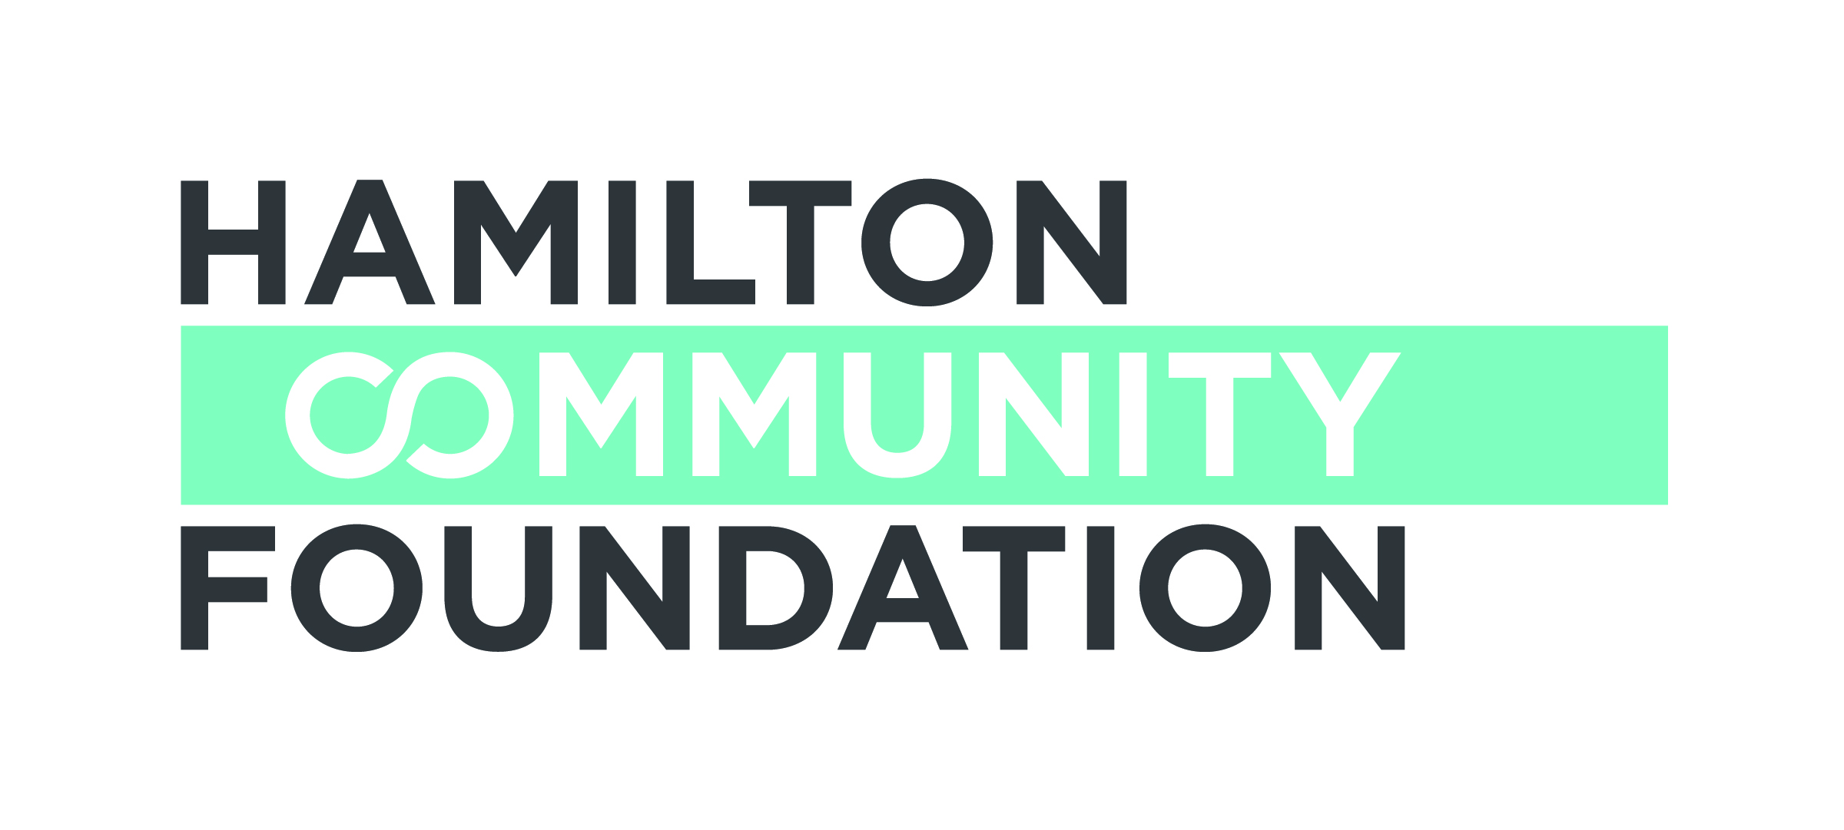
YOUTH-LED GRANTS: 2014-15
Grant Application

This program provides seed funding for youth-led community projects, encouraging youth to address environmental and social justice issues in their schools and communities.

Please note: Salaries and wages are not eligible for funding. Groups that receive a grant are expected to provide project reports, including budget reports and receipts, and may be asked to participate in helping us evaluate the program.

Section A- General Information

Name of group, class, organization, school: ______________________________________________________________________

______________________________________________________________________
Address: __________________________Postal Code __________________________

Adult Advisor: __________________Youth Representative ______________________

E-Mail: __________________________ Phone #:____________________________

Charitable Registration Number: ___________________________________________
Name of Charitable Registration Number Sponsor (if applicable): __________________

Section B - Grant Information (use additional space if required, but please limit your response
to no more than three pages)
- Title/name of your project/activity:

2. How much money are you requesting for a youth-led grant?

3. Provide a brief description of your group:

4. Please estimate the total number of people involved.

5. Who will be involved in your project? (e.g. students, teachers, community members, others) What will they be doing?

6. What environmental/social justice issue(s) will be the focus for your project/activity? How do you plan to address these issues?

7. Briefly describe your project/activity and what you want to achieve (what you want to do, why do you want to do it, and what do you intend to accomplish?)

8. How are youth involved in planning and implementing this project?

9. Over what period is the project activity taking place?
Project/activity start date:________________
Project/activity end date: _______________

10. How do you plan to evaluate the success or difficulties with your project?

11. Additional Comments (please use this section to include any relevant information not covered above, or any other information that will help us to better understand your project)

Section C – Project/Activity Budget

1. What is the total amount (in dollars) of your project/activity budget?

2. Please give us an itemized list of how Hamilton Community Foundation’s youth-led grant would be used and provide the approximate dollar amount per item.
ITEM | DESCRIPTION | COST
 | Budget Total

3. Please list other sources of revenue (if any) for this project/activity. Include any in-kind contributions.

Section D: Signatures

This application for a Youth-led grant has been approved by the school or overseeing organization:

__________________________________ __________________________________
Signature of Principal (if applicable) Name (print) of Principal

Date: _____________________________

__________________________________ ___________________________________
Signature of Adult Advisor Name (print) of Adult Advisor

Date: _____________________________

__________________________________ ___________________________________
Name (Print) of Youth Project Representative Signature of Youth Project Representative

Date: _____________________________

DEADLINE for YOUTH-LED GRANT APPLICATIONS IS FEBRUARY 23, 2015

Please return completed applications by mail or fax to:
Co Chairs, Youth Advisory Council
Hamilton Community Foundation
120 King Street West, Suite 700
Hamilton ON L8P 4V2 Fax (905) 523-0741

Inquiries and Information:
Hamilton Community Foundation Web site: www.hamiltoncommunityfoundation.ca
Melissa Ricci, Adult Advisor, Youth Advisory Council
Phone (905) 523-5600 x 264 / Email m.ricci@hamiltoncommunityfoundation.ca

