TROUBLESHOOTING GUIDE

HCF’s Grants Management system – REPORTING

# Before you start:

**Content in your reporting (requirement) forms WILL NOT AUTOSAVE as you type. Please click “SAVE” periodically so you don’t lose your work. We suggest you type your content in a Word document, then copy and paste it into the requirement form.**

**Need to change your organization’s email address?**

HCF’s grant reporting system sends a report link directly to the original applicant’s email address. This person may differ from the person responsible for your organization’s reporting. If this is the case, you may transfer the Application/Report form by following these steps:

**If you are the Sender:**

* 1. Login to your account and look for the document you wish to transfer
  2. In the “Actions” column, select “Transfer to New Owner” (option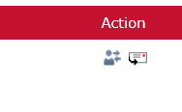)
  3. Fill in the new person’s name and email address and then hit the “Transfer” button. **Note:** If the new person does not already have an account on HCF’s grants management system, they will receive a second email which provides set-up instructions

**If you are the Receiver:**

* 1. As the new person you will receive an email containing a link to the report
  2. Navigate to the “Requirements” tab

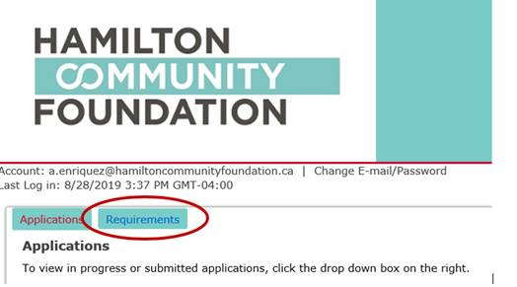

* 1. They must click “Accept All Transfers” as shown below.

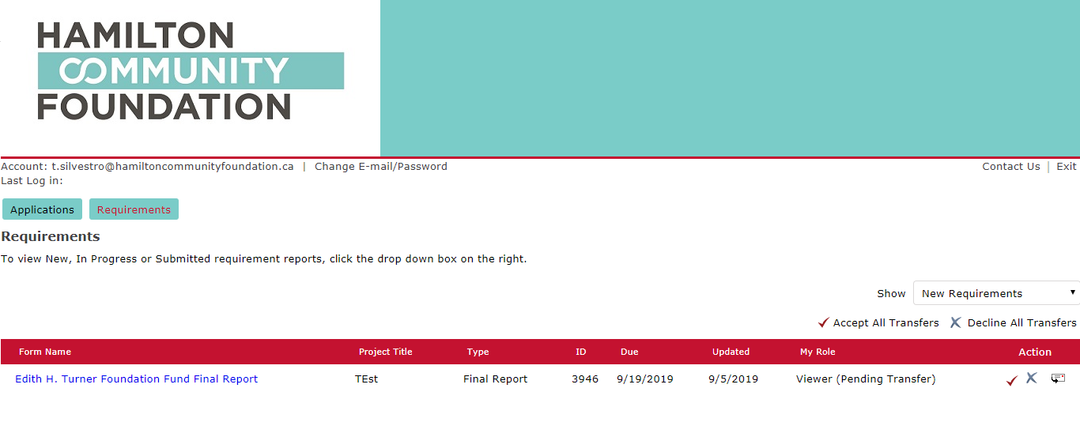

# Re-opening your partially completed report:

**Please note:** Saved reports do not re-open properly. HCF is aware of this challenge, and apologizes for any inconvenience. To resolve the issue, please clear your browser history, clear your “cookies” and then re-open the report. If you continue to experience technical issues, please contact Tami Henderson [t.henderson@hamiltoncommunityfoundation.ca](mailto:t.henderson@hamiltoncommunityfoundation.ca) or (905) 523-5600 x 241.

**How to begin to write your report:**

1. Login to HCF’s grants portal by clicking on the link provided in the email which is: <https://www.GrantRequest.com/SID_5831?SA=AM>
2. Navigate to the “Requirements” tab



1. Once in the “Requirements” tab, please make sure to click on the correct view. The default is set to “New Requirements”, **however**, if you have previously ‘saved and closed’ your report, you can retrieve it by clicking “In Progress Requirements” from the drop down menu on the right hand side.

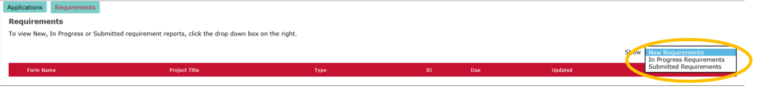

\\domain\hcfdata\Data\Operations\IT\Gifts on line implementation\Requirements\Troubleshooting guide - Requirements.docx