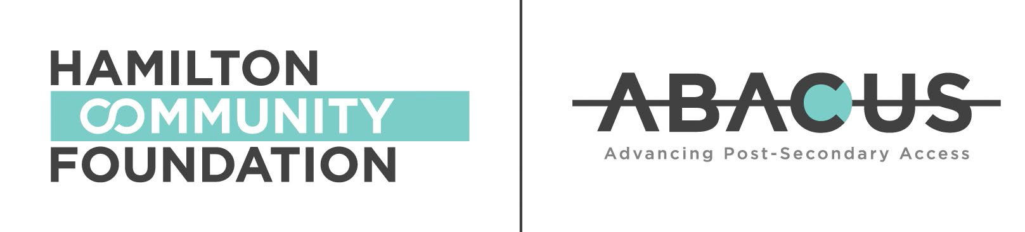

ABACUS Phase II: Equity, wellness, academic achievement
ABACUS, a collaborative initiative of Hamilton Community Foundation and The Fairmont Foundation, is a 10-year commitment to education. Its goal is to increase the likelihood that young people facing multiple barriers graduate high school and access postsecondary, by focusing on the pivotal middle-school years.

Two new granting calls will open at the end of February and close May 2, 2022 at 5:00 p.m. for programs that run in the 2022-23 school year. There will be an information session March 10, 2022, 1:00 to 2:30 p.m.for organizations to learn more about the programs and applying to them.
Each of these calls reflects a refocusing of ABACUS to address particular needs uncovered through the Foundation’s research, experience and community consultation, including input from grantees. In particular, the refinements include an increased focus on the transition to high school, reading acquisition and numeracy in the earlier years, overall social and emotional wellness, and addressing the needs of students historically underserved in the education system.

ABACUS+
This call is for programs that support the overall development of children, focusing on their social, emotional and academic learning. Programs must serve students in the middle-school years (Grades 6, 7 and 8) and/or those transitioning into secondary school (Grade 9 and the start of Grade 10).
ABACUS is based on the understanding that students and their families start thinking about life after high school early; during their middle-school years. Another critical period in a student’s academic journey is the transition into secondary school.
Students are adapting to a new environment – a larger group of classmates, more teachers, and a semestered way of learning. Research shows that academic success in Grade 9 is a strong predictor of high school completion and postsecondary access.

HCF’s focus is on supporting programs serving students who continue to be underserved in the education system. This includes Indigenous, Black and racialized students; Two-Spirited and LGBTQIA+ students; students who are first- generation attenders (i.e. whose parents did not attend post-secondary); and students who are: newcomers, male, have special education needs, have disabilities, have disciplinary records or who are from low-income families. HCF will prioritize programs that take an intersectional approach to meeting the unique needs of these student groups.

New: ABACUS Liftoff!
This call is for programs that address the reading and numeracy of Hamilton students in Grades 4 and 5. HCF will prioritize programs that focus on the overall well-being of students in addition to their learning outcomes, as well as programs that serve students who already face barriers to education. An environmental scan of education-based programs in Hamilton revealed that very few programs are focused on older elementary children. Research has also shown that learning loss during the pandemic is more pronounced in elementary students as opposed to secondary students. Furthermore, while this fund is focused on learning outcomes, it is important for programs to address the pandemic’s adverse effects on the overall health of students, and that some student groups have been affected more than others.

Background
Originally the three components of ABACUS were:
  - Grants to programs that expanded Hamilton’s capacity to provide supports during the middle-school years
  - Grad Track, a three-year pilot using a learning coach to deliver intensive programming to a small group of students
  - Bringing partners together to identify and address systemic barriers to post- secondary education
Through this work, the Foundation gained insight into Hamilton’s educational landscape. In a review conducted at the mid-point of our 10-year commitment, evidence pointed to recommendations for refinements that would enable ABACUS to best meet community needs, including:
  - A deeper focus on student populations who face persistent and pervasive barriers in the education system and taking an intersectional approach to meeting their needs
  - Expanding investment to include the transition period into the middle-school years (Grades 4 and 5), with a particular focus on addressing learning interruptions arising from the pandemic
  - Increasing support for the transition out of the middle-school years and into high school, including Grade 9 and the transition into Grade 10
  - Exploring alternative granting models that expand HCF’s outreach, increase accessibility of funds, and include community partners in decision-making. This includes examples like proactive granting.
We want to thank our education partners and grantees for the insights you shared during this re-think process. We have, and will continue to, learn from you about how best to support Hamilton students and their families. Implementing these recommendations will be a gradual process, and there will be more opportunities for you to inform ABACUS Phase II.

