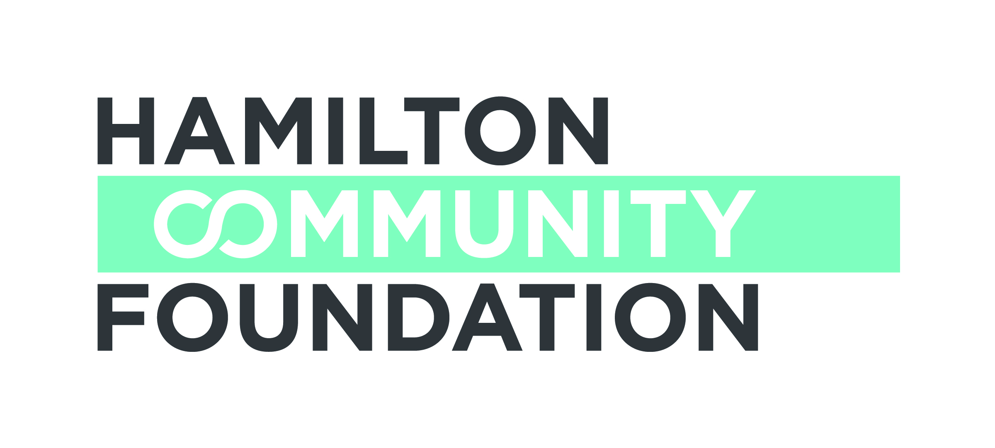

FINAL REPORT (GENERAL)

DUE DATE:

Hamilton Community Foundation requests that you use the following form to prepare a final report on your project. We encourage you to share your insights into what worked, what did not and changes you might make to improve your progress. Your candor and open feedback not only informs us of your progress but provides us with valuable learning experiences that assist us and help other non-profit organizations at the same time.

We ask that you be concise and limit your narrative report to two pages, however feel free to attach detailed evaluation results if appropriate.

Section A

Grantee/organization name: Click or tap here to enter text. Grant # Click or tap here to enter text.

Telephone:Click or tap here to enter text. Email: Click or tap here to enter text.

Contact Person: Click or tap here to enter text.

Report prepared by (if different than above): Click or tap here to enter text. date: Click or tap here to enter text.

Sponsor name/organization (if applicable): Click or tap here to enter text.

Project title: Click or tap here to enter text.

Report covers period from Click or tap here to enter text. to Click or tap here to enter text.

Number of people served: Click or tap here to enter text. children Click or tap here to enter text. youth Click or tap here to enter text. Adults Click or tap here to enter text.

Total cost of project Click or tap here to enter text. Total amount of HCF grant Click or tap here to enter text.

Section B – Narrative

Please follow the format outlined below and ensure that your report does not exceed two pages. Click or tap here to enter text.

Project Activities
- Briefly describe your key project activities during the grant period.

Project Outcomes
- What specific outcomes did you achieve for your target population or community? How did the participants or target audience benefit from your project?
- What changes or improvements, if any, did you make in the project design or delivery to better meet the needs of your target population?
- Describe any unanticipated challenges or successes.
- How did you work with community partners/organizations?
- Were you able to attract other funding support for this initiative?

Sustainability
- Do you intend to continue this project? If so, how will it be funded? If not, why? How are you progressing in obtaining other sources of support?
- What is your vision for this project over the next three to five years?

Learnings
- What were the key learnings from doing this project? If you were to do it again, what would you change?

Evaluation
- How did you evaluate your project, and if so, what did you learn?

Vignette
- Please provide one interesting example of how your project is making a difference

Recognition
- How was this grant acknowledged?

Attachments

- Detailed Financial Statement showing project revenues and expenditures
- Copies of any media coverage
- Photographs of activities relating to the funded project (if appropriate). Please note that Hamilton Community Foundation uses photographs submitted by grantees in annual reports and other publications. We require a waiver to be submitted with any photograph including project participants allowing for the use of the photograph by the Foundation (available on our website at www.hamiltoncommunityfoundation.ca)
- Evaluation reports (if available)

